Dis-Asia-Indus-Seal-Harappa-300-2500 BCE-Collection-final

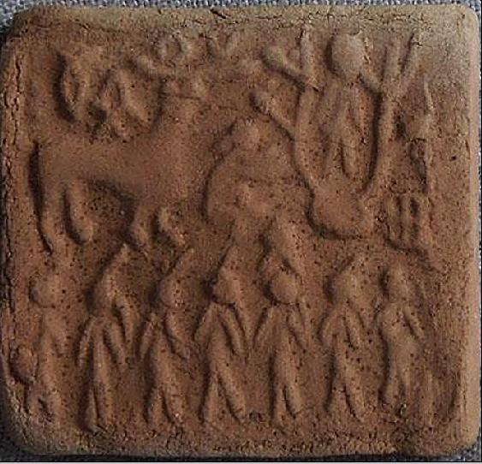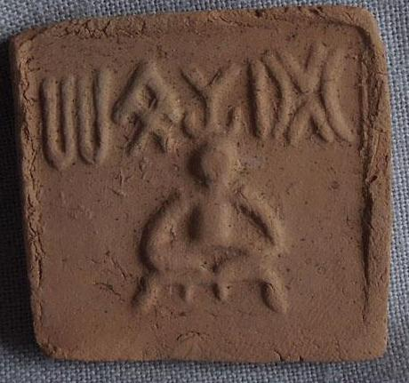

1. Ceremony 2. Proto Shiva

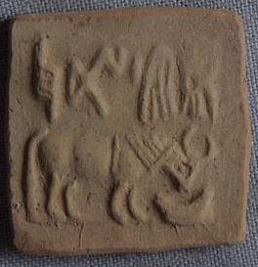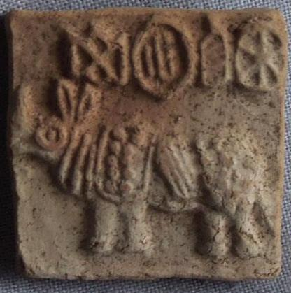

3. Bull 4. Animal

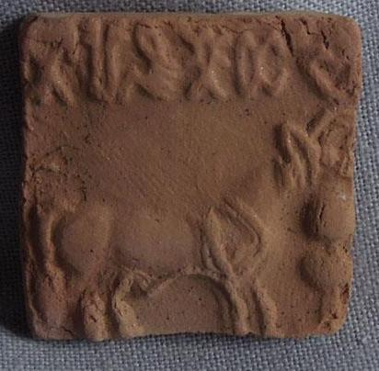

1. Animal

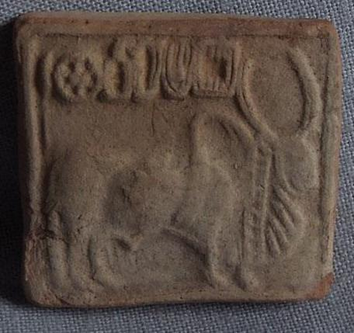

6. Sacred Brahman Bull

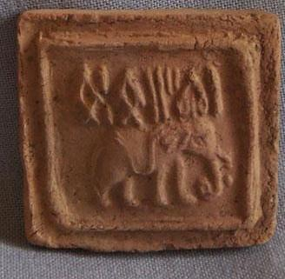

7. Elephant

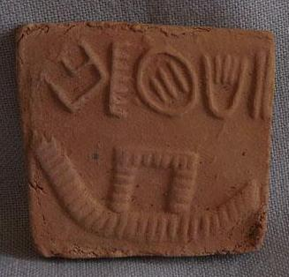

8. Maritime Vessel

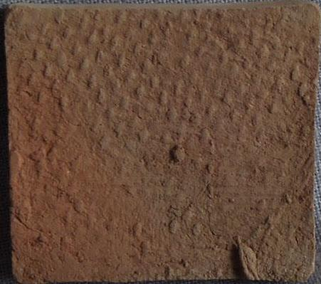

1.

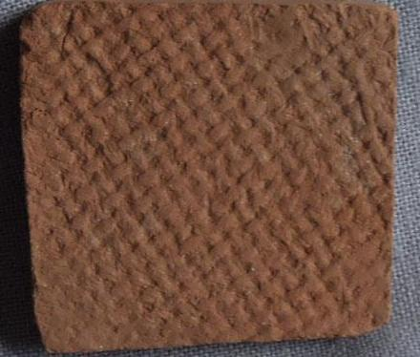

2.

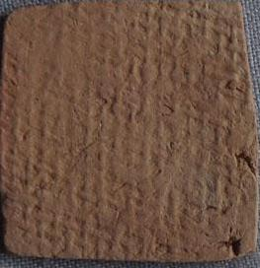

3.

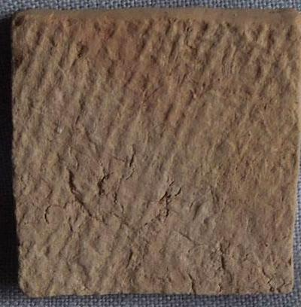

4.

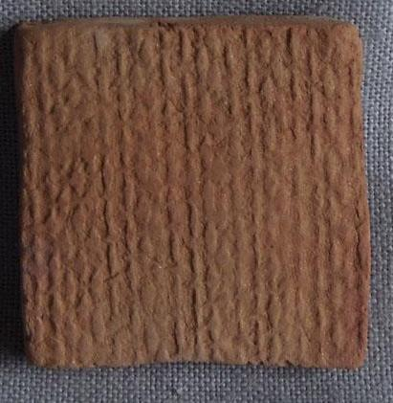

5.

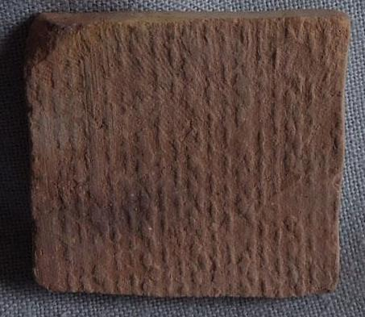

6. Stuctured surface

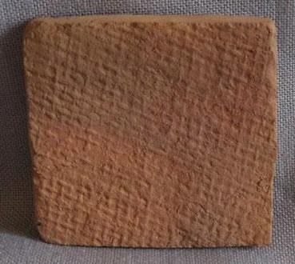

7.

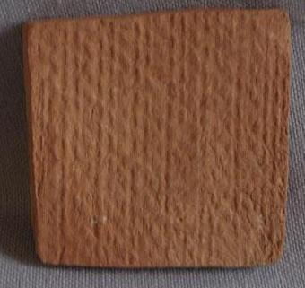

8.

Sold by [tribal*focus](http://myworld.ebay.com/tribal*focus) ( [6609](http://feedback.ebay.com/ws/eBayISAPI.dll?ViewFeedback&userid=tribal*focus) )

### Delivery package 1 of 1

Estimated delivery Wednesday, May 4, 2016 - Thursday, May 12, 2016

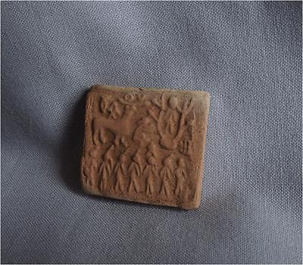

#### [Antique Pakistan TOP HIGH AGED INDUS HARAPPA CLAY SEALING TABLET WITH CEREMONY](http://www.ebay.com/itm/301931583913)

|  |  |
| --- | --- |
| Item price | $59.90 |
| Quantity | 1 |
| Item number | 301931583913 |
| Shipping service | Standard Shipping |

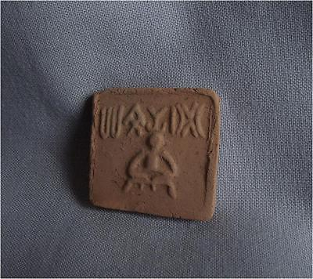

#### [Antique Pakistan TOP HIGH AGED INDUS HARAPPA CLAY SEALING TABLET WITH PROTOSHIVA](http://www.ebay.com/itm/301931584682)

|  |  |
| --- | --- |
| Item price | $64.99 |
| Quantity | 1 |
| Item number | 301931584682 |
| Shipping service | Standard Shipping |

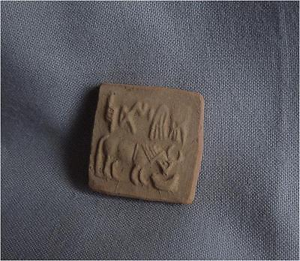

#### [Antique Pakistan TOP HIGH AGED INDUS HARAPPA CLAY SEALING TABLET WITH ANIMAL](http://www.ebay.com/itm/301931585165)

|  |  |
| --- | --- |
| Item price | $59.90 |
| Quantity | 1 |
| Item number | 301931585165 |
| Shipping service | Standard Shipping |

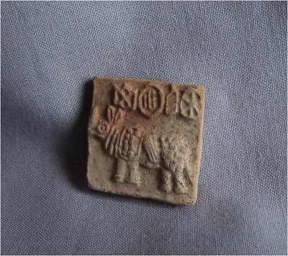

#### [Antique Pakistan TOP HIGH AGED INDUS HARAPPA CLAY SEALING TABLET WITH ANIMAL](http://www.ebay.com/itm/291739618198)

|  |  |
| --- | --- |
| Item price | $61.00 |
| Quantity | 1 |
| Item number | 291739618198 |
| Shipping service | Standard Shipping |

## Shipping address

Ralph J Coffman Jr

149 Atlantic Ave

Swampscott MA 01907-2427

United States

## Order total

|  |  |
| --- | --- |
| Subtotal | $245.79 |
| Shipping | $20.00 |

**Total**

$265.79

Order placed on

Saturday, Apr 23, 2016

Payment method

Credit card

Payment date

Saturday, Apr 23, 2016

### Delivery package 1 of 1

Estimated delivery Friday, Jun 3, 2016 -Friday, Jun 10, 2016

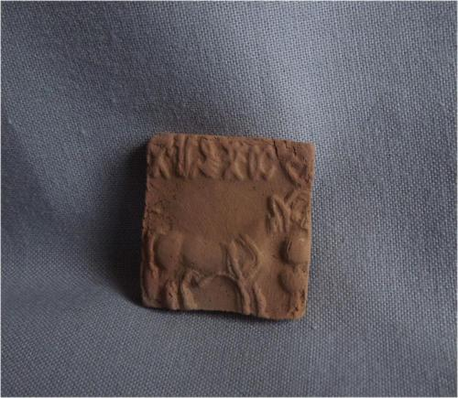

#### [Antique Pakistan TOP HIGH AGED INDUS HARAPPA CLAY SEALING TABLET WITH ANIMAL](http://www.ebay.com/itm/291764146046)

|  |  |
| --- | --- |
| **Item price** | $59.90 |
| **Quantity** | 1 |
| **Item number** | 291764146046 |
| **Shipping service** | Standard Shipping |

[Contact seller](http://contact.ebay.com/ws/eBayISAPI.dll?FindAnswers&frm=3998&iid=291764146046&redirect=0&requested=tribal*focus)

[Return item](https://www.ebay.com/rtn/Return/ReturnViewSelectedItem?transactionId=0&itemId=291764146046&_trksid=p2057872.m2749.l3185)

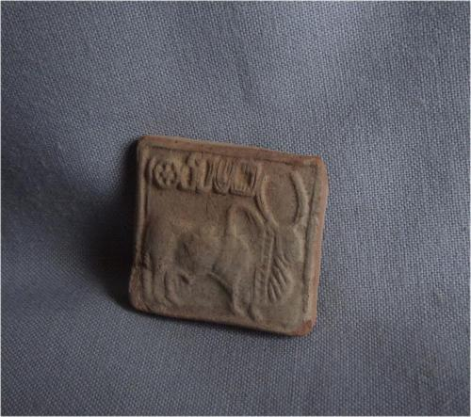

#### [Antique Pakistan TOP HIGH AGED INDUS HARAPPA CLAY SEALING TABLET WITH ANIMAL](http://www.ebay.com/itm/291764146385)

|  |  |
| --- | --- |
| **Item price** | $59.90 |
| **Quantity** | 1 |
| **Item number** | 291764146385 |
| **Shipping service** | Standard Shipping |

[Contact seller](http://contact.ebay.com/ws/eBayISAPI.dll?FindAnswers&frm=3998&iid=291764146385&redirect=0&requested=tribal*focus)

[Return item](https://www.ebay.com/rtn/Return/ReturnViewSelectedItem?transactionId=0&itemId=291764146385&_trksid=p2057872.m2749.l3185)

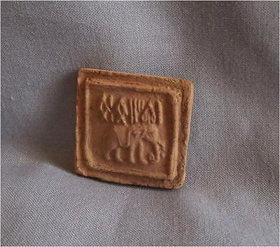

#### [Antique Pakistan TOP HIGH AGED INDUS HARAPPA CLAY SEALING TABLET WITH ANIMAL](http://www.ebay.com/itm/291764146791)

|  |  |
| --- | --- |
| **Item price** | $84.00 |
| **Quantity** | 1 |
| **Item number** | 291764146791 |
| **Shipping service** | Standard Shipping |

[Contact seller](http://contact.ebay.com/ws/eBayISAPI.dll?FindAnswers&frm=3998&iid=291764146791&redirect=0&requested=tribal*focus)

[Return item](https://www.ebay.com/rtn/Return/ReturnViewSelectedItem?transactionId=0&itemId=291764146791&_trksid=p2057872.m2749.l3185)

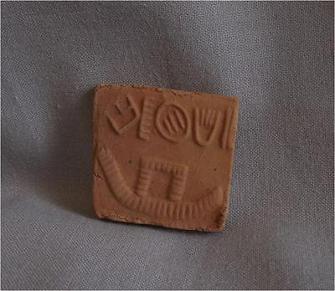

#### [Antique Pakistan TOP HIGH AGED INDUS HARAPPA CLAY SEALING TABLET WITH BOAT](http://www.ebay.com/itm/291764147397)

|  |  |
| --- | --- |
| **Item price** | $59.90 |
| **Quantity** | 1 |
| **Item number** | 291764147397 |
| **Shipping service** | Standard Shipping |

# Order details

Printer friendly page

## Sales order

Sold by [tribal*focus](http://myworld.ebay.com/tribal*focus) ( [6662](http://feedback.ebay.com/ws/eBayISAPI.dll?ViewFeedback&userid=tribal*focus) )

+ Show additional actions

### Delivery package 1 of 1

Delivered on Wednesday, May 4, 2016

+ Show shipping details

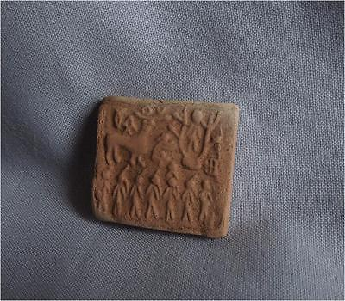

#### [Antique Pakistan TOP HIGH AGED INDUS HARAPPA CLAY SEALING TABLET WITH CEREMONY](http://www.ebay.com/itm/301931583913)

|  |  |
| --- | --- |
| **Item price** | $59.90 |
| **Quantity** | 1 |
| **Item number** | 301931583913 |
| **Shipping service** | Standard Shipping |

[Leave feedback](http://feedback.ebay.com/ws/eBayISAPI.dll?LeaveFeedbackShow&useridfrom=802-867&useridto=tribal*focus&item=301931583913&transactid=0)

[Contact seller](http://contact.ebay.com/ws/eBayISAPI.dll?FindAnswers&frm=3998&iid=301931583913&redirect=0&requested=tribal*focus)

[Return item](https://www.ebay.com/rtn/Return/ReturnViewSelectedItem?transactionId=0&itemId=301931583913&_trksid=p2057872.m2749.l3185)

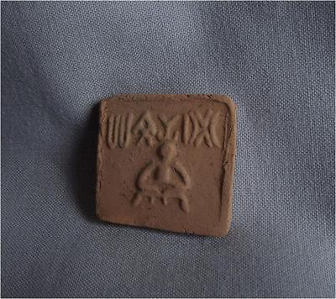

#### [Antique Pakistan TOP HIGH AGED INDUS HARAPPA CLAY SEALING TABLET WITH PROTOSHIVA](http://www.ebay.com/itm/301931584682)

|  |  |
| --- | --- |
| **Item price** | $64.99 |
| **Quantity** | 1 |
| **Item number** | 301931584682 |
| **Shipping service** | Standard Shipping |

[Leave feedback](http://feedback.ebay.com/ws/eBayISAPI.dll?LeaveFeedbackShow&useridfrom=802-867&useridto=tribal*focus&item=301931584682&transactid=0)

[Contact seller](http://contact.ebay.com/ws/eBayISAPI.dll?FindAnswers&frm=3998&iid=301931584682&redirect=0&requested=tribal*focus)

[Return item](https://www.ebay.com/rtn/Return/ReturnViewSelectedItem?transactionId=0&itemId=301931584682&_trksid=p2057872.m2749.l3185)

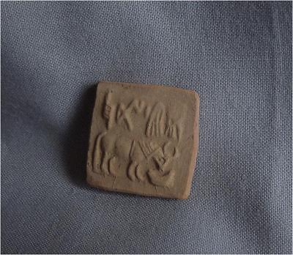

#### [Antique Pakistan TOP HIGH AGED INDUS HARAPPA CLAY SEALING TABLET WITH ANIMAL](http://www.ebay.com/itm/301931585165)

|  |  |
| --- | --- |
| **Item price** | $59.90 |
| **Quantity** | 1 |
| **Item number** | 301931585165 |
| **Shipping service** | Standard Shipping |

[Leave feedback](http://feedback.ebay.com/ws/eBayISAPI.dll?LeaveFeedbackShow&useridfrom=802-867&useridto=tribal*focus&item=301931585165&transactid=0)

[Contact seller](http://contact.ebay.com/ws/eBayISAPI.dll?FindAnswers&frm=3998&iid=301931585165&redirect=0&requested=tribal*focus)

[Return item](https://www.ebay.com/rtn/Return/ReturnViewSelectedItem?transactionId=0&itemId=301931585165&_trksid=p2057872.m2749.l3185)

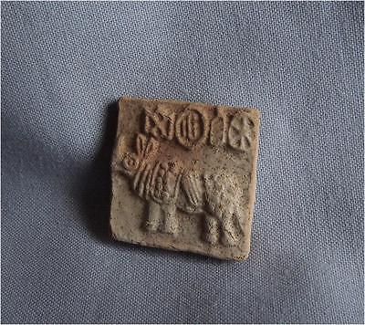

#### [Antique Pakistan TOP HIGH AGED INDUS HARAPPA CLAY SEALING TABLET WITH ANIMAL](http://www.ebay.com/itm/291739618198)

|  |  |
| --- | --- |
| **Item price** | $61.00 |
| **Quantity** | 1 |
| **Item number** | 291739618198 |
| **Shipping service** | Standard Shipping |

[Leave feedback](http://feedback.ebay.com/ws/eBayISAPI.dll?LeaveFeedbackShow&useridfrom=802-867&useridto=tribal*focus&item=291739618198&transactid=0)

[Contact seller](http://contact.ebay.com/ws/eBayISAPI.dll?FindAnswers&frm=3998&iid=291739618198&redirect=0&requested=tribal*focus)

[Return item](https://www.ebay.com/rtn/Return/ReturnViewSelectedItem?transactionId=0&itemId=291739618198&_trksid=p2057872.m2749.l3185)

## Shipping address

Ralph J Coffman Jr

149 Atlantic Ave

Swampscott MA 01907-2427

United States

## Order total

|  |  |
| --- | --- |
| **Subtotal** | $245.79 |
| **Shipping** | $20.00 |

**Total**

$265.79

## Shipping address

Ralph J Coffman Jr

149 Atlantic Ave

Swampscott MA 01907-2427

United States

## Order total

|  |  |
| --- | --- |
| Subtotal | $43.67 |
|  | |

|  |  |
| --- | --- |
|  | |
| Import charges | $0.00 |

**Total**

$65.50

*Pricing based on current conversion rates